**KIBABII UNIVERSITY**

**DIGITAL AND ANALOG COMMUNICATION**

**CAT 1**

1. Using suitable diagrams and equations explain how AM is achieved. (Given carrier signal is Wc MHz and information signal is Wm Khz where both waves are sinusoidal) [6marks]

2. State the equation for AM modulation index [2marks] 3. State the equation for FM modulation index [2marks]

4. Sketch a labeled diagram of the frequency spectrum of an AM wave [6marks]

1. **Draw a block diagram of** CDMA spread spectrum and explain how the system operates. [8marks]
2. Differentiate between GSM technology and CDMA Technology [6marks]
3. Explain about Voice Over Internet Protocol. [6marks]
4. Describe 3 types of noise in telecommunication and electronics [8marks]
5. Baseband in the transmission of communications signals means only one path is available to send and receive digital signals between devices. Describe the various ways in which baseband is used [4 marks]
6. In order to transmit [computer](https://www.britannica.com/technology/computer) data and other digitized information over a communications channel, an analog carrier wave can be modulated to reflect the binary nature of the digital baseband signal. Explain ASK, FSK and PSK digital modulation techniques [6 marks]
7. Periodic waveforms are those that vary [periodically](https://en.wikipedia.org/wiki/Periodic_function), they repeat regularly at consistent intervals. State 4 Parameters of Periodic Wave Forms [4 marks]

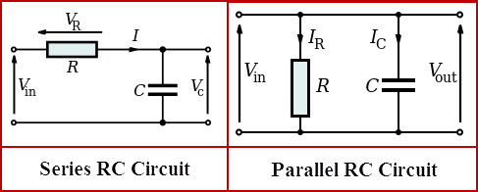

Explain how the above RC Filter works [4 marks]